**SAMPLE OUTPUT SCREENSHOTS FOR ARITHMETIC CALCULATOR**

**ADDITION OF TWO NUMBERS:**

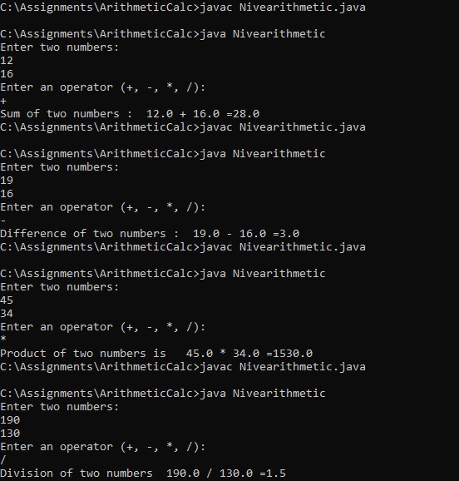

**DIFFERENCE OF TWO NUMBERS:**



**PRODUCT OF TWO NUMBERS:**



**QUOTIENT OF TWO NUMBERS:**

